Kubernetes Task -2

Step1:

Creating the directory of eks using Ec2 Instance and mkdir inside the eks created after that we need an deployment , service and vpa file those also created

Screenshot Mentioned Below:

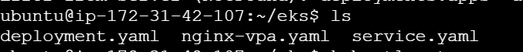

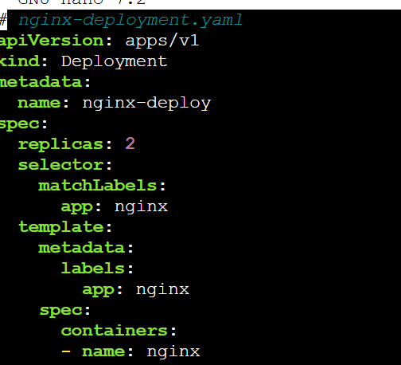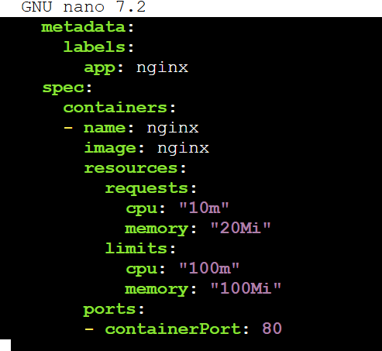

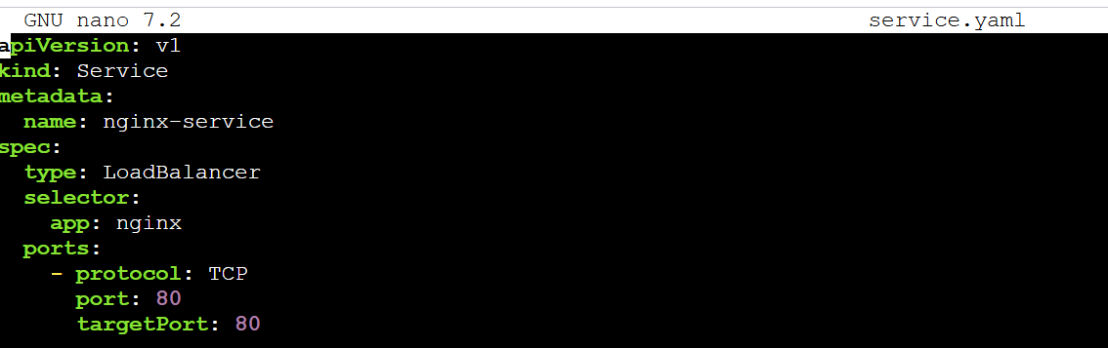

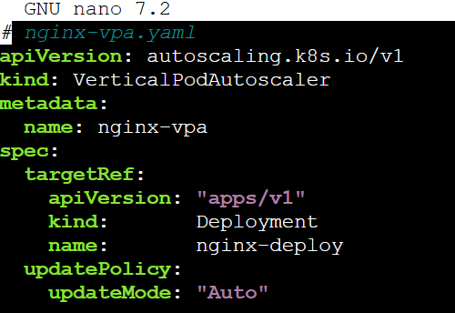

All those File are created and to run those service we have an command is

Kubectl apply –f <name-created.yaml>

Step2:

And service if created then we can see the pods are running using get svc pods

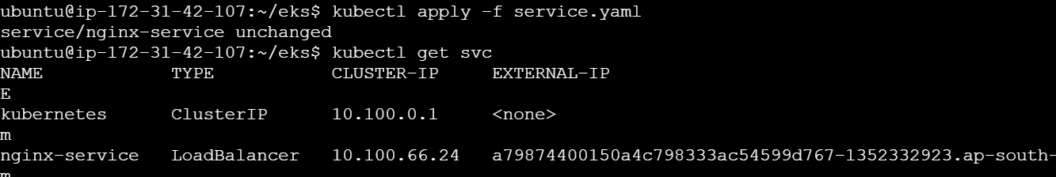

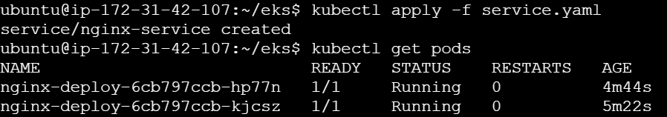

Step3:

And if we hit the Load balancer ip we can see the Output from the outside the cluster

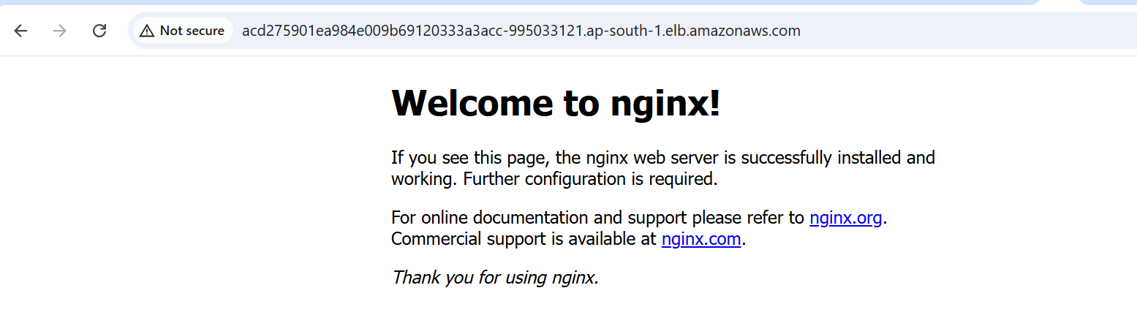

So Benefit of creating the VPA is for if any I resources will access on the server then autoscaling will taken care of node size will change on what we configured in file